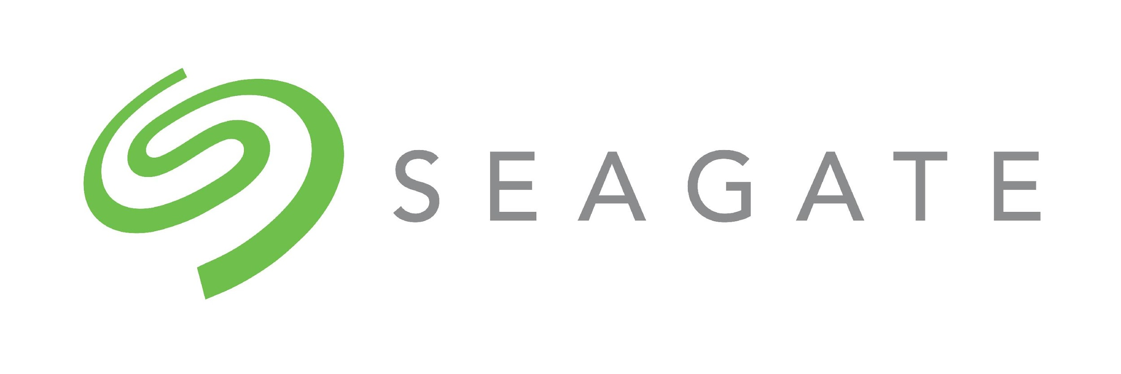
Application for Seagate $1500 FRC Grant for the 2018/2019 Season

Seagate is offering three $1500 grants to FRC teams for the 2018/2019 season. Preference will be given to diverse teams and teams with a Seagate affiliation (Seagate employees related to team members, or Seagate employees mentor the team). One of the three grants is targeted to a new less-resourced team.
Team Number:
Team Name:
Number of Years Team has Competed:
Team Affiliation and Location:
Adult Leaders/Team Contacts (name, email, phone):

Team members, years on the team and team role(s):
Name | Years on team | Team Role(s)
Add more lines if needed
List Seagate employees with team roles (coach/mentor/parent, and number of relatives on team):
Employee Name | Team Role | # of related students on Team
Add more lines if needed

Please answer the following questions: - Brevity is appreciated, 300 word limit per question
Add lines as needed

- What are your team’s objectives for this season?
- What are examples of your team’s community outreach?
- What are your teams diversity statistics?
- How will this grant help support your team? Provide a budget summary

As a condition of this grant, Seagate expects quarterly updates, an end of year summary, as well as a demonstration of the robot (schedule permitting).

Please submit your grant applications to robotics.mn@seagate.com by Mon., Nov. 26, 2018. Decisions will be communicated on Nov. 30.

